**Unit 10 assignment 1**

**Section 1**

People make films for many reasons and factors for example the entertainment or the artistic value, there are many different versions of film some include; short film or festivals, competition, showing off talent, feature length productions, drama, political filmmaking, TV drama and issues-based narrative filmmaking. These are just a few. Non-fiction films are films which have been zoned into reality and usually have a hidden meaning behind it, such as societal problems. Fiction films allow an audience to escape from reality and enjoy a film that is almost impossible to happen in real life.

Fiction films are made for many reasons, for entertainment, for the artistic style of it, for profit or even for the pure joy of it. Fiction films can come in different forms for example festivals where mostly amateur film makers show off their films. Competitions and talent shows are also very similar to festivals where film makers can show off their films however unlike festivals there is usually a prize for the best film or short film. Feature length films, entertainment and drama films can be made for many reasons some are just to entertain a massive fan base for example marvel has a very large fan base and when it was originally created purely for entertaining the fans. These are all seen in the movie “lord of war” as the movie has many different characteristics for example it has very humorous moments but very serious moments furthermore the film has examples of drama and overall the film takes on many forms and genres but by far the most obvious and expressive is the crime genre, people want to watch this if the main genre is crime as it can be some people’s favourite genre and they will want to watch it if they know they will enjoy it, furthermore it could have been made for the value of money as if the producer know people will enjoy it then they will bring money from the box office.

**Section 2**

The film “Lord Of War” starring Nicolas Cage, has many codes and conventions for the crime genre some are the use of; alcohol and illegal substances, weaponry, a failed attempt from the police force, robbery and potential relates to a hard upbringing or back story from the protagonist, murder mystery, and more. The protagonist is motivated to change his life decisions when he is involved with the ‘wrong type’ of people and starts to sell guns every now and then another reason is to change his life as his old job was working at his parent’s restaurant which by the looks of things aren’t very clean as the scene in the restaurant doesn’t do a good job at making the restaurant look beautiful, and by the looks of things this was their intention as it allows for the audience to understand why he wants to get a different job. The movie is non-linear as the start is a short scene where Yuri is taking about the miss use of guns, this scene is also scene at the end, making the film in non-chronological order and making the film cynical. The main character Yuri is seen as the protagonist however he is more of a anti protagonist instead as what he is doing isn’t for the good as he is just selling guns to the wrong type of people, however the ‘hero’ title isn’t given to Yuri but rather to “Jack Valentine” as he is trying to do the right thing and trying to bring Yuri in for selling guns and illegal weapons. The film appears to have a very distinct structure, for example it follows Todorov’s narrative theory where the film as sections which change the course of key events which alter the outcome of the film. the film has an equilibrium where the protagonist hasn’t got much of a life and finds a new job which is very dangerous, this is also seen in a film called ‘Baby Driver’ at the start the young adult’s life is just looking after his grandfather. The film as a disruption where his and other lives are threatened and are at stake, also seen in ‘Baby Driver’ when he disobeys the orders and goes rogue. To when the realisation of the chaos and the main problem which is when the protagonist has seen what his gunrunning sales are being used for. The film has the quest to restore order, which is when the chaos is fixed. However, in the film the chaos isn’t resorted but instead the protagonist goes back to what he used to do selling guns this is where the quest to restore order fails and a new equilibrium is the result of the failure which creates a twist from all the other stereotypical crime films, as most of them follow the structure of Todorov’s theory a key example is ‘Baby Driver’ this film follows the structure from start to finish and this has many crime genre features just like ‘Lord Of War’. Furthermore, the use of stereotypical stock characters and characterisation such as the gang members, mafia, Russian army and many more. However, the film changes what the audience are expecting as Yuri is an anti-hero where he is the overall ‘bad guy’ however the film makes you fond of him by creating a backstory which later makes you want him to win. The classic stock characters consist of many for example: ‘the big shot’ and ‘the action hero’. The story is very open ended however it does end as expected from the audience for example, the ani-hero wins and continues with his life and the FBI don’t catch him, this is how a crime film needs to end where one or the other catches or gets away as without that the story will just continue or leave on a cliff hanger. Furthermore, the story ends with the protagonist talking directly into the camera and the audience talking about what looks like a public awareness campaign, this leaves the story open ended as there are many possibility’s that can happen with it. The movie is in some ways considered as a typical crime film however it is left on a cliff hanger but this cliff hanger isn’t as big as the one from the ‘Italian job’ for say. The films narrative closing established the genre as it is the same as the opening creating a full loop or a cyclical structure, this creates an effect where the audience is brought on an adventure or a story with the protagonist feeling all kinds of emotions just like him and experiencing all kinds of sights. This is typical of the crime genre as the audience expect features of crime to be shown off in the film and by not showing this is any way will get the audience’s expectations down for other crime films and it will make them not want to see them anymore.

**Section 3**

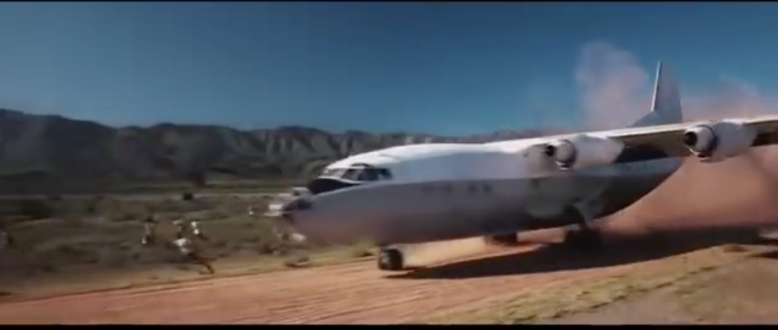Mise-en-scene is very important in establishing the genre, this is created using characters, setting, props, figure expression and through Barthes semiotics codes. In the opening of the film the mass number of bullets along the floor suggest it’s a stereotypical crime movie. Furthermore, the contrapuntal music could suggest that the movie may have a humorous side to it. Furthermore, the setting of the factory tells the audience that the movie shows many codes and conventions of the crime theme and the stereotypical crime setting or ‘safe-house’ is applied here. Throughout the opening the protagonist is made very clear however at the start he is seen as a stereotypical ‘good guy’, also as he narrates the entire movie the audience are given the feeling of him being the protagonist, Throughout the movie Yuri goes on a journey which really immerses the audience with the film, this is achieved using settings for example when Yuri is in Africa the crew and cast were taken over there to film the scene. A dirt track and has a very stereotypical African landscape with bare hills, along the civilians behaviour as they are walking bear feet as they don’t have the luxury of shoes, furthermore the costumes in the African setting are very accurate as the children and adults are dressed in old cloths that are worn through or they hardly fit at all. Furthermore, the use of props helps the audience understand the codes and conventions in the African scene all the people only have baskets made out of straw filled with cloths from, when they take the guns they drop all their belongings on them in excitement. The setting is a very generic for an African road where it’s made out of dirt and overcrowding is a problem. The camera angle has a couple of different types of shots the main shot is by far the establishing shot as it used throughout the opening and ending of the scene this is used to allow the audience to understand the setting. However, this isn’t a typical crime genre set as they are usually placing where there is a lot of money to take or someplace which has value or even a rundown section of town. Another type is the close up shot, this is used to emphasize the excitement on the poor African people. In the scene natural lighting is mostly used with slight sights of overhead this give the impression that the days are long but they can be used to effectively help people and save yourself. The sound establishes the genre as it is a very stressful music which is a common feature of a crime film or movie the use of non-diegetic sounds help the audience understand and feel the stress that Yuri is going through and this is a very common feature of a crime film. However these subvert the stereotypes of a crime genre which gives of the impression that this film is trying to make a hybrid of multiple genres.

**Section 4**

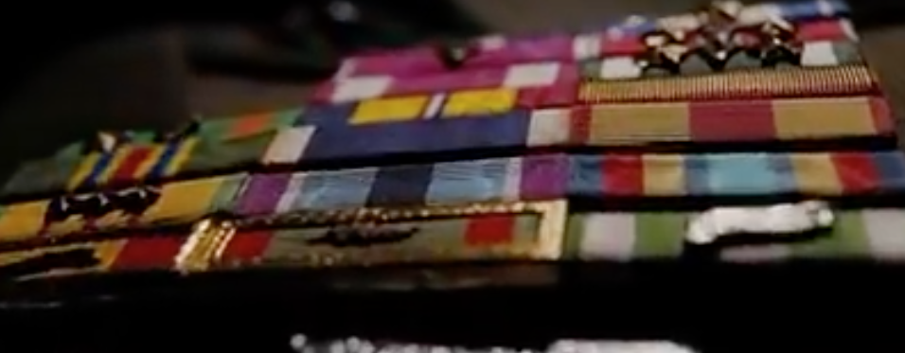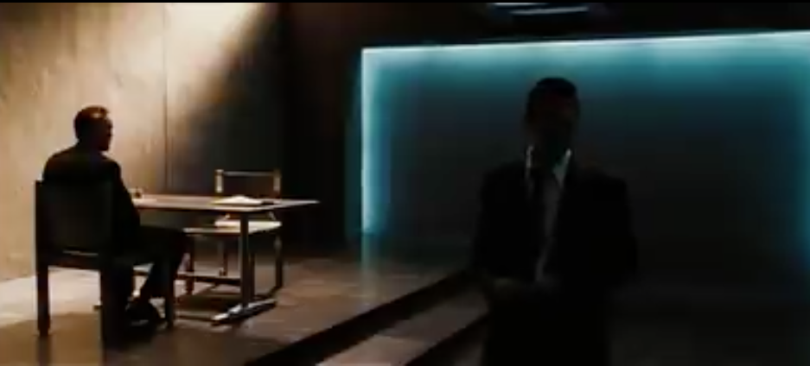In the interrogation scene, towards the end of the film which is placed between the ‘quest to restore’ and the ‘new equilibrium’. Jack valentine interrogates Yuri to bring him in and bring justice. This scene is a clear representation of ‘good and evil’ criminality and justice’ between Yuri and Jack Valentine as when the camera is on Yuri the background is mainly a bright golden yellow beam clearly representing the light or hope for the protagonist along with the colour the feeling of warmth comes along to the audience clearly on which side is going to win, furthermore when the camera is on Jack Valentine the background light is a cold blue colour clearly representing how cold hearted Jack Valentine really is and shows the audience the stereotypical crime genre. Throughout this scene Yuri is calm and sat down in a chair while Jack is having a go at him creating suspense for the audience and raising questions about his body language giving a very stereotypical crime film, this is also known as sophisticated articulation. As Yuri is calm and looked unbothered by this it makes the audience stay on the edge of their chair. Not much sound is being played throughout the scene creating a suspicious and suspense scene this changes the narrative as by having Yuri calm it suggest that Yuri knows he is going to get out without a problem.

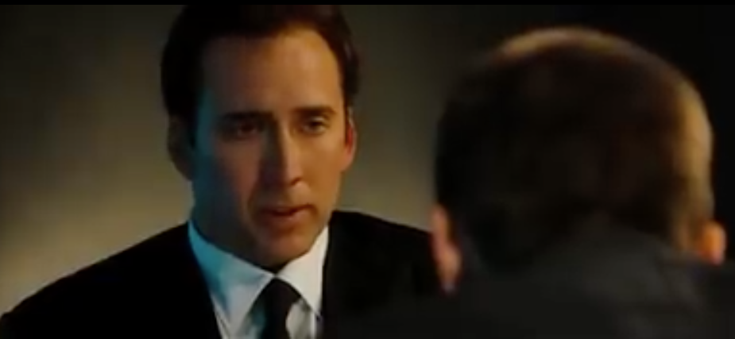Throughout the scene the use of low key lighting is a clear representation of a crime film as it is a very commonly used code and convention of a crime film, this low key lighting creates the effect on the audience that they are in Yuri’s position and can feel all the emotions he can. At the start of the scene the use of a bullet bringing Yuri in for justice is a typical crime feature as it is using a heavily reliant feature of the crime genre, however the audience don’t tend to expect a interrogation scene which creates a unexpected change for the crime genre which overall makes the pace of the film slower as their isn’t fast pace music which would also sound wrong but make it fast but it won’t feel naturally fast such as a gun fight for example. In the scene Yuri is in a chair in the middle of an empty room creating the impression that he is in a jail cell and there is nothing around him to help. The use of contrapuntal sound really gives the effect that this crime film is more serious than the audience really thought at the beginning of the film. The use of close ups and mid shots are a very typical feature of a crime film as it allows the audience to find the expression on their faces and body language more satisfying to the event or time for example when the camera is at a overhead mid shot is captures Yuri and he is clearly relaxed and although he looks disappointed he knows what is going to happen to him, this allows the audience to engage and it creates a very typical crime film in the point of view of the audience. The use of over the shoulder type angles allows the audience to have a clear view of one character while still having a view on the other character allowing to see both characters body language easily and understand how they fell in the situation that they are in. The use of a main dark background colour helps represent the theme for the audience and makes it look more realistic to the audience.

**Section 5**

Both ‘Lord Of War’ and ‘John Wick Chapter 2’ are crime hybrid genres however I will be focused on the crime aspect of the films. The opening narrative openings are contrasting as lord of war is designed to create and provide an exposition and has a cyclical structure, however the other jumps straight into an action scene, this is an instant continuation of the first ‘John Wick’ film and starts where it finishes, this is the equilibrium of the film where John Wick is doing his ‘job’ by getting revenge and this is the balance of the film where everything is as it should be. In the opening to John Wick Chapter 2 the film is borderline anti realist as there is a high speed chase with gun fire everywhere in the middle of a city late at night. ‘Lord Of War’ is very realist as the film has very real issues such as children using guns, or selling guns and illegal substances to buyers, this contrasting as both films are very heavily typical for a crime genre, as they both include typical crime genre features such as characterization and typical props such as guns, drugs and many more. In John Wick the film doesn’t follow a 3-act structure as there is no resolution as it ends on a cliff hanger where John Wick falls off a building and stays alive. Thus making it not typical however ‘Lord Of War’ does follow a 3-act structure making a very typical crime film, this is typical as the crime film usually has a resolution the 3rd act where everything goes back to the way it is or the villain is caught. Throughout the film the protagonists have different motivations as Yuri Orlov’s motivation is to get out of his parent’s restaurant and make a new life however John Wick’s motivation is to get revenge for getting a bounty put on his head. Just by hearing this John Wick’s motivation is already a very clear aspect of crime however Yuri’s motivation could lead him anywhere he was just lead into the wrong profession. Todorov’s narrative theory of the 5-act structure of the equilibrium, disruption, recognition, an attempt to repair the damage and the new equilibrium, only applies to Lord of War this is contrasting as John Wick doesn’t follow this. Lord of war is highly non-liner as there are many different story lines throughout the film however John Wick is liner as the narrative moves along in a chronological order, this is contrasting to ‘Lord Of War’ as that film is non-linear and is cynical. In both films, the use of characterisation is heavily used as in John Wick the protagonist is very stereotyped he is smartly dressed with excellent hitman type skills, furthermore the typical gang members. This is very similar to lord of war as both protagonists are smartly dressed however Yuri isn’t a hitman, however there are very typical gang members and the failed police force as well as the Russian Army. These are all very typical for the crime genre. Throughout the representation of men and women as seen in very different ways in each film, as in John Wick Chapter 2 the women are seen as fighters or trained assassins this is subverting the stereotypes of women as they are usually seen as house wives, submissive which is seen in Lord of War. So far I believe that ‘John Wick’ portrays the crime genre better and is overall more conventional as it meets most of the stereotypes that audiences are expecting to see. In ‘Lord Of War’ the ending becomes the beginning which is creating a full loop as the beginning is the same as the ending and this is a cyclical structure this is commonly referred to close ending leaving the audience with satisfaction and no further questions are asked about the ending. However in John Wick the film ends on a cliff hanger also known as open ending where the audience are left to wonder what might happen next, this isn’t typical for a crime film as they usually don’t have open endings as this is also subverting the conventions of a crime film. This is contrasting towards Lord of War as the closed ending is very typical for a crime film. Therefore, Lord of War is a very stereotypical crime film and meets the expectations of a crime narrative overall embracing the crime genre’s expectations, as John Wick doesn’t meet the crime genre’s expectations this isn’t a bad thing for say it just lets the audience use their imagination to think of what’s going to happen next. This creates a different style of crime films, furthermore it isn’t necessarily typical to end a film in this way however it gives a sense of creativity on what is happening next as the narrative could lead to film in any way creating more suspense for the 3rd John Wick film.

**Section 6**

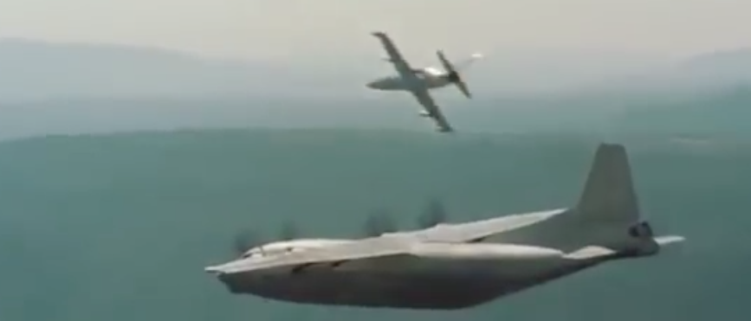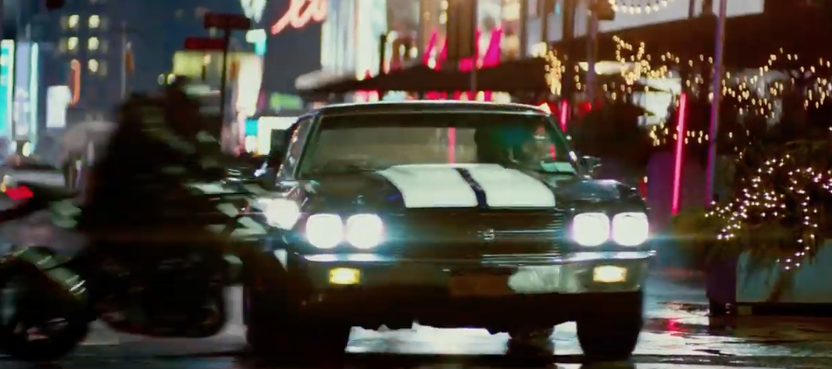Both Lord of War and John wick have chase scenes in Lord of War Yuri is getting attacked by the police, this scene has many different stylistic codes and conventions such as the lighting in the plane is very dull with muted colours which gives a very serious atmosphere that helps build tension to see if Yuri is going to get taken down, this is very similar to John Wicks chase scene where the use of dull, muted colours are used however the natural lighting which is at night adds more to the atmosphere and gives more tension which ‘Lord Of War’ doesn’t, in these chase scenes I believe that ‘John Wick’ does a better job at trying to get the crime genre across to the audience. Within the chase scene in ‘Lord Of War’, Yuri makes the piolet land on a dirt track with many civilians with their lives at risk. In the cargo hold of the plane, Guns such as AK-47 and many different types of weaponry found hidden away as props. Furthermore, the plane looks like its run down. The use of suits is a common convention of a crime genre. Furthermore the use of assassins as seen in movies such as John Wick wears suits to help establish the genre as it’s instantly recognisable. The use of action shots is used a lot during this scene this helps establish the genre as it will help the audience realize that is a crime film as this a very common camera shot to capture the key events of the film in the best speed which keeps this separate from an action film. Furthermore, the action shots give the feeling of satisfaction when something fast pace is happening. Throughout the scene many different camera angles help the audience establish the genre for example the use of close ups help understand the feelings and expressions that Yuri is feeling, furthermore the use of establishing shots helps the audience see what’s happening as without this the audience won’t be able to see the jet plane coming from behind them and this will confuse the audience this is very common for any genre however its very common for crime films as it allows the audience to see features that the protagonist cant until the last second, this really for fills the audience’s expectations for the crime genre and the film overall. The use of natural lighting helps the audience see what’s going on however it could resemble to the light and hope in Yuri as he is the protagonist, furthermore the shadows are emphasized in the plane to show that Yuri has many different ‘faces’ where his appearance changes depending on who he is with or what’s happening within the scene.

**Section 7**

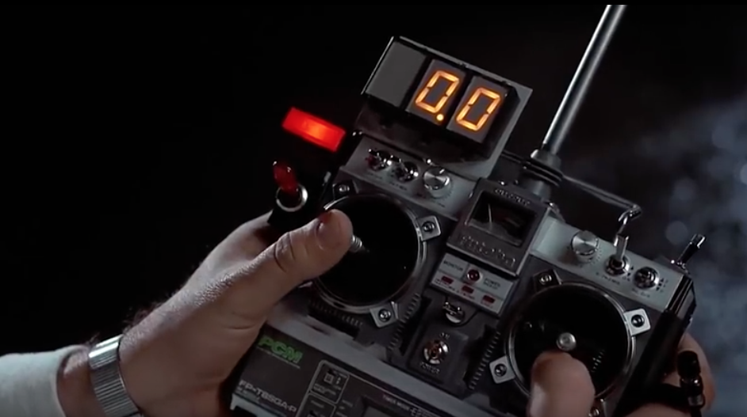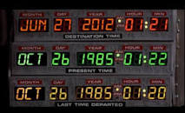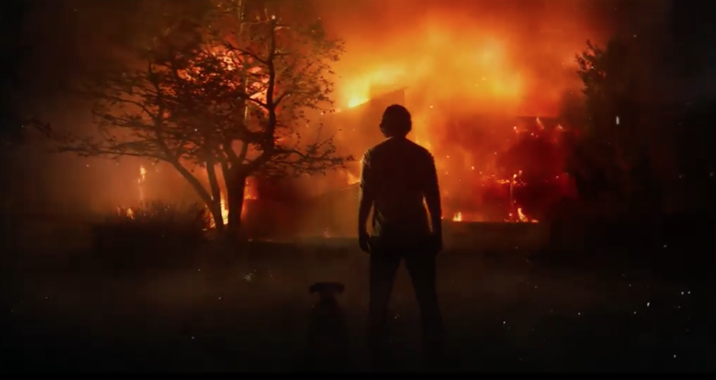I will now complete an analysis of a Science Fiction film. In the film ‘Back To The Future’, Todorov’s narrative theory can be applied however I will focus on the disruption. In ‘Back To The Future’ the genre can show the disruption, because the film is all about time travel and accidently going back in time, its genre is adventure and science fiction and when Marty gets sent to the past, specifically 1955 from 1985. In Back to the Future the binary oppositions theory by Levi Strauss are a main feature of the film as the binary opposite between 1985 when Marty lived his life and 1955 where Marty’s parents lived their life and how both generations are effected by Marty accidently going back in time and running into both of them on the same day and potentially critically effecting Marty’s future or his present. In the scene where Marty goes back in time he is driving away from the labial Doc’s new invention is shown off and a large cloud of smoke appears as the back of a trailer opens up and the DeLorean rolls out, the use of close up of the DeLorean showing off the futuristic technology and parts of the DeLorean that are ‘flashy’ to the audience. The film has very stereotypical character types for example the crazy scientist that discovers time travel and creates crazy inventions and the teenager as a sidekick who goes on crazy adventures with the scientist, this even led to an animated knock off called Rick and Morty which is almost identical to ‘Back to the Future’ in the character sense. Back to the Future has many key themes, for example the theme of ambition in Back to the Future as Marty is trying to get back to his original time in 1985 as he has been sent back to 1955 by mistake. Another theme is Fate and Free Will, for example in Back to the Future Marty could have given up and accepted that he now lives in 1955 however he doesn’t as choses to get back to 1985 and for fill his and his family's fate. These are all very typical for the science fiction genre as when an invention has gone wrong something even worse happens like a rebound effect. This is seen in the film ‘The Martian’ which is also a science fiction film and when their trip back to Earth from Mars the capsule gets broken and a astronaut is left behind on Mars all alone. This is a clear representation that in most science fiction films an invention goes wrong and something worse happens.

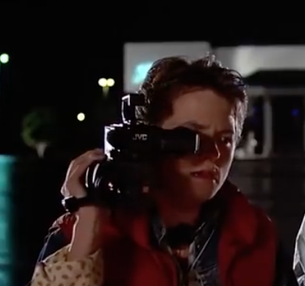In the scene where Doc shows off the DeLorean for the first time the deserted mall parking lot show how secret this invention really is and how dangerous it can be so reveal is at night and at 1am where no one else should be up and looking at them. The use of natural lighting with the street lights and head lights from the DeLorean makes the audience feel one with the film and feel like they are in Marty and Doc’s shoes. The remote control that is linked up to the DeLorean justifies the science fiction genre as the idea of having a car hooked up to a small remote seems far-fetched and unlikely however this does look very homemade and built from scratch or adapted from a toy which looks very futuristic as the close up on the remote control shows off the technology to the audience, Furthermore the use of Marty filming this invention gives the value of historically accurate form someone watching this film in the 21st century this shows 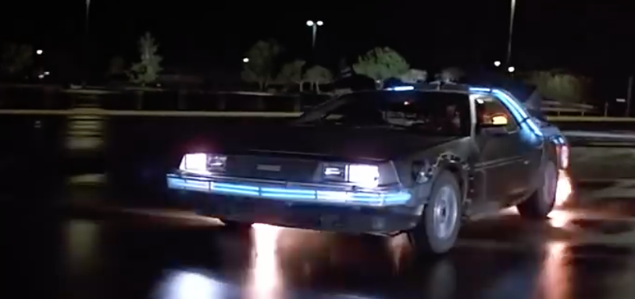the genre of the film as they are two features of science fiction of from 1985 as then there wasn’t many ‘futuristic’ products and they were only really seen in comic books or tv programs. Furthermore, the DeLorean Time machine has been changed to look very futuristic as it’s got wires all over and pipes with neon coloured lights flashing over it and the chrome like finish with a matt coat is a very iconic science fiction feature as in many different science fiction films such as star trek the space ship has chrome and a matt finish on it. These are clear expectation of the science fiction genre as the chrome colour has a futuristic feel to it, and the video recorder looks very modern for the time and the controller has been changed it with extra buttons which do other 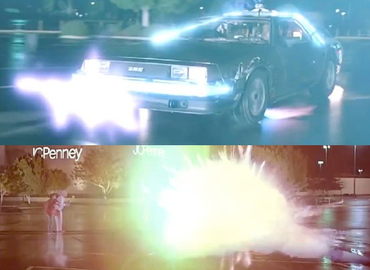things to the car for example revving the engine, changing gear, accelerating and more these are common conventions of the Science fiction genre as the idea of the ‘futuristic’ is just changing the looks or appearance of a product which the Doc in ‘Back To The Future’ does very well on the DeLorean. Finally the heavy use of special effects is a common appearance in science fiction films as without the effects the films won’t appeal to the audience for example when the DeLorean goes forwards or backwards in time a bright light and ‘lightning’ effects appear with a trail of fire where the tires would be, and without this the DeLorean would just vanish into thin air and the audience would get very tired of seeing that over and over again.

**Section 8**

In conclusion people watch films of many different genres to escape from reality or to feel comfort, however many people watch the same genre for similar and different reasons maybe it reflects their personality or they enjoy the entertainment, many different audiences appeal to them as it could be a time to show off on a artistic value, people watch different genres as they create expectations and it allows them to understand the film easier as they are familiar with the genre and will understand the main feature or features of the film. The three movies have expectations from their genre as ‘Lord of War’ and ‘John Wick’ main genre is Crime and typical crime features such as guns and drugs and the use of fighting scenes and action shots with the camera work, the use of intense music and the repeated pattern of using guns and weapons to fight are constantly repeated so the audience knows and is reminded of what the genre is. In Back to the Future the genre is adventure and science fiction and this movie has a very clear quest sending Marty back to 1985 from 1955, furthermore the science fiction genre is repeated through the use of time travel and the time machine. The uses of and gratifications such as escapism and entertainment makes the films more engaging and interesting, the use of surveillance / information gives the audience a reason to watch the film, and finally the use of social interaction between characters gives a more compelling and interesting relationship between them. Overall all three movies gives very clear representations of their genre and do this very well. Finally both crime and science fiction films have lots to offer and they do this in many different ways, through the use of special effects or the failed police force, the cray inventions and technology or the guns and illegal substances. It is impossible to say what genre is better as it is opinion based, however I do believe that ‘John Wick’ does a better job at showing off the crime genre than ‘Lord Of War’ as I believe that John Wick has more crime aspects to offer such as; the use of weaponry, however this is used in both films heavily but I believe that John Wick has more use of weapons than ‘Lord Of War’ as that film is about selling guns more than using guns. Emphasizes of the protagonist struggles which again is seen when in ‘Lord Of War’ when Yuri loses his wife and family, however I think that ‘John Wick’ has more to get revenge on as he also loses his wife but he also loses his house and his dog. Therefore I believe that ‘John Wick’ does a better job at showing of the crime genre.