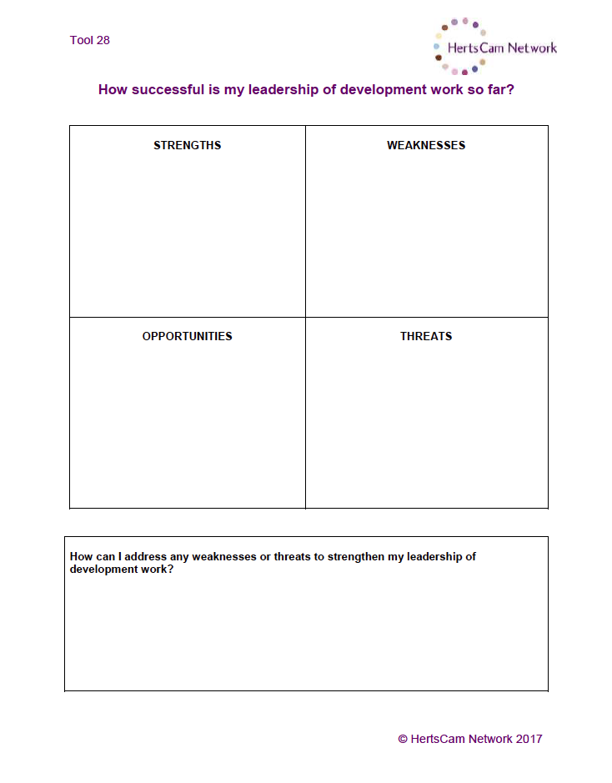

Be reasonable – especially when it comes to working with other members of staff; not adding to their workload.

Be flexible and accommodating

Be a little more concise and precise with the delivery and outcomes of my project; be more focused.

Liaise with other colleagues

Liaising with industry professionals

Re-educating about misconceptions; stigma of BTEC

Time!!!!

Workload

Other members of staff not participating

Project is currently too large and needs scaling back.

What do I want the actual outcome of the project to be? This is still a little muddled

Very well rehearsed in this area and have the tools to explore a range of avenues; teachers, students, teachers of other BTEC subjects.

Access to a range of resources

Very well organized action plan